Module 5 Assignment
Ollie Connett
Southern New Hampshire University
DAT 300

For this assignment, the sales organization is wanting to address the following questions from the data that they provided:
1. Which deal sizes yield the largest volumes?
2. Which territory generates the largest amount of sales?
3. In which months do we see the largest volume of sales?
For question one, a visualization can be shown to answer the question:
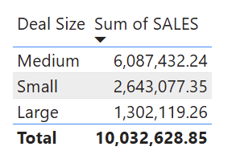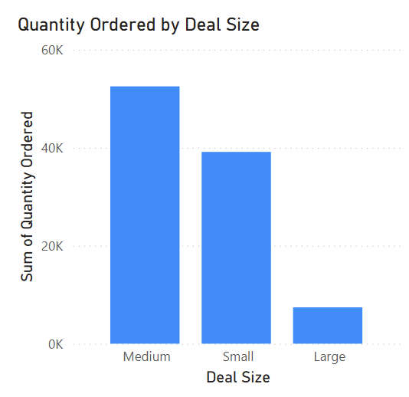
When comparing the sum of sales to deal size found in the data set, it appears the medium deal sizes are the most frequently ordered followed by small, and then large. Medium size deals total to $6,087,432.24 in sales, while large deal sizes only total to $1,302,119.26.
For the second question regarding the territory that generates the largest number of sales, there is not enough information provided to answer this question. There is no instance of any location information found within the data set. To answer this question, more information is needed regarding the geographical information of each sale such as state/territory or city.
For question three, a visualization can be created to answer the question:
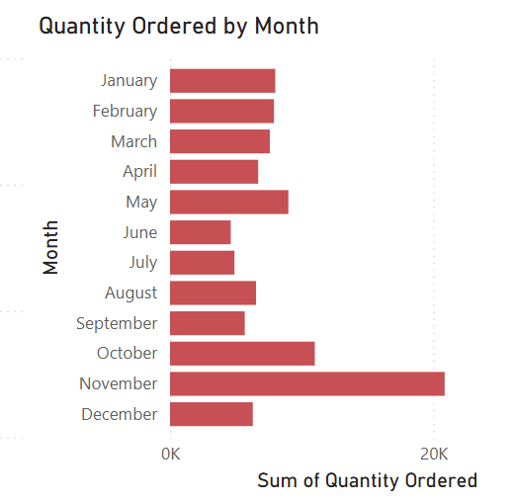
Within the order-dates provided in the data set, it appears that most sales occur during the months of November, October, and May. The months with the least number of sales include June, July, and September. This indicates that of the fiscal year, quarter four generates the highest of sales on average, while quarter three generates the least.

